In the first 30 minutes it was open, a supermarket sold 4/5 of its packages of toilet paper leaving only 10 packages on the shelves. Kami bought 2 packages. What percent of the packages the supermarket started with did Kami buy?

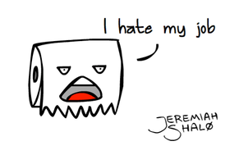
A) 2%
B) 4%
C) 10%
D) 20%
E) 80%

If $\frac{4}{5}$ of the packages were sold, $\frac{1}{5}$ were left.
There were 50 packages to start with since 10 is $\frac{1}{5}$ of 50.
2 is 4% of 50.

